# IOT Home automation assessment

## Code:

// C++ code

//

float temp;

void setup()

{

pinMode(6,INPUT);

pinMode(12,OUTPUT);

Serial.begin(9600);

}

void loop()

{

if(digitalRead(6)==HIGH){

tone(12,523,1000);

Serial.println("Unknown detected");

}

else{

noTone(12);

}

temp=analogRead(A1);

temp=temp*0.48828125;

if(temp>=110.84){

tone(12,100,2000);

Serial.print("Above 60 c Temperature...");

}

else{

noTone(12);

}

}

## Circuit Diagram:

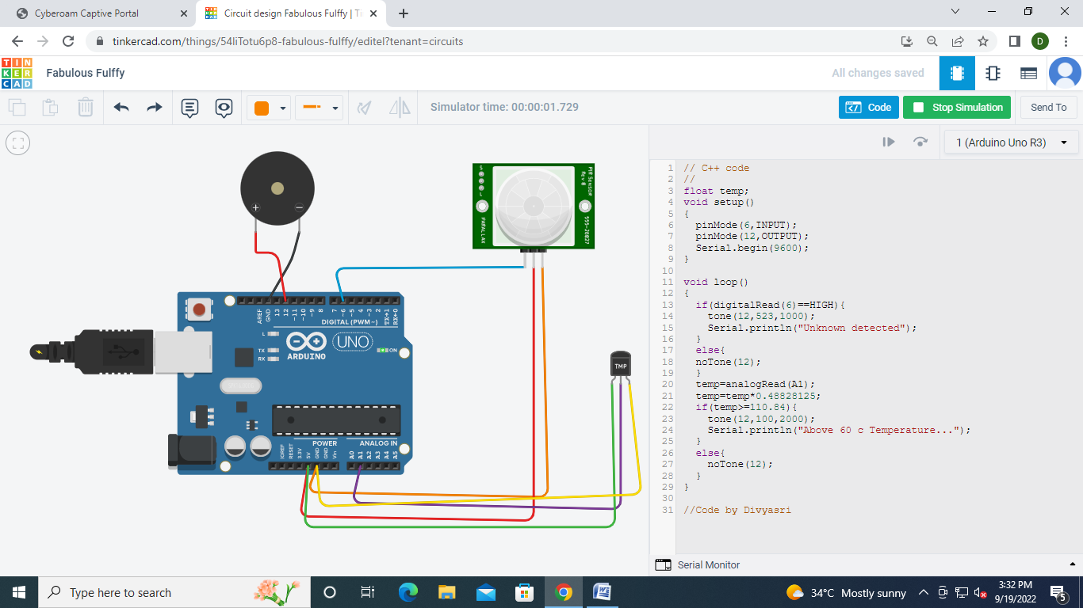

## Output:

PIR Sensor

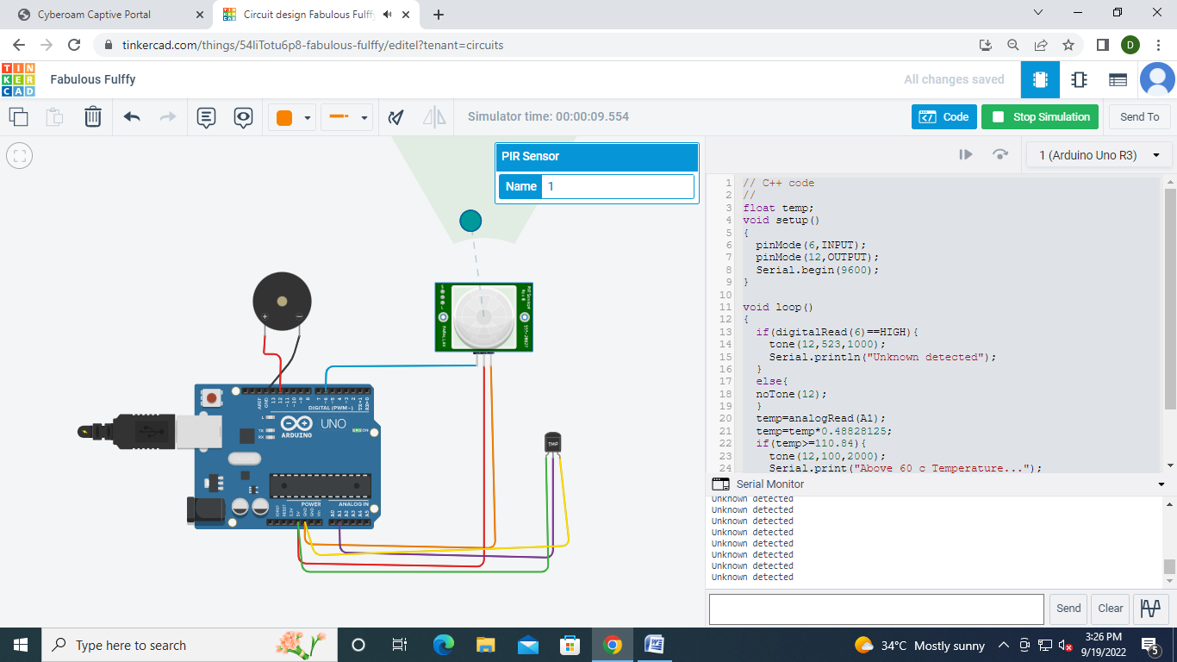

Temperature Sensor

